# Import Retail Strategies

This document describes the steps needed to move retail strategy/merchandise group data from a BlueCube database instance or spreadsheet to and ESO database instance.

## Required Files

In the Retail Strategies subject folder of the data extraction and loading package program files, there are 4 SQL scripts.

Step 1 - Retail Strategies Extract Source DB (Optional)

Step 2 - Retail Strategies Insert Dest DB

Step 2 - Retail Strategies Insert Dest DB (Spreadsheet Based)

Step 3 - Retail Strategies Create Strategies

## Extract Source DB (Do not use if importing from a spreadsheet)

Open an instance of SQL Server Management Studio and then open a new query window. Set the database to the main BC/ESO database.

Open and Execute the query “Step 1 - Retail Strategies Extract Source DB”. This query will create a bc_extract_retail_strategy table and populate the table with the existing set of retail strategy.

Right Click on the database names and navigate to tasks, generate scripts.

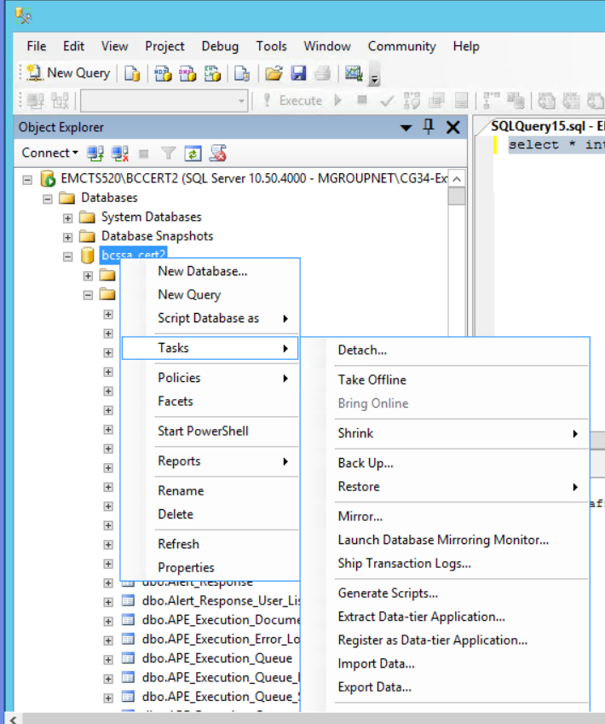

The script generation tool will be displayed.

Select the option to “Select specific database objects”. Expand the list of tables and select the bc_extract_retail_strategy table.

Click Next

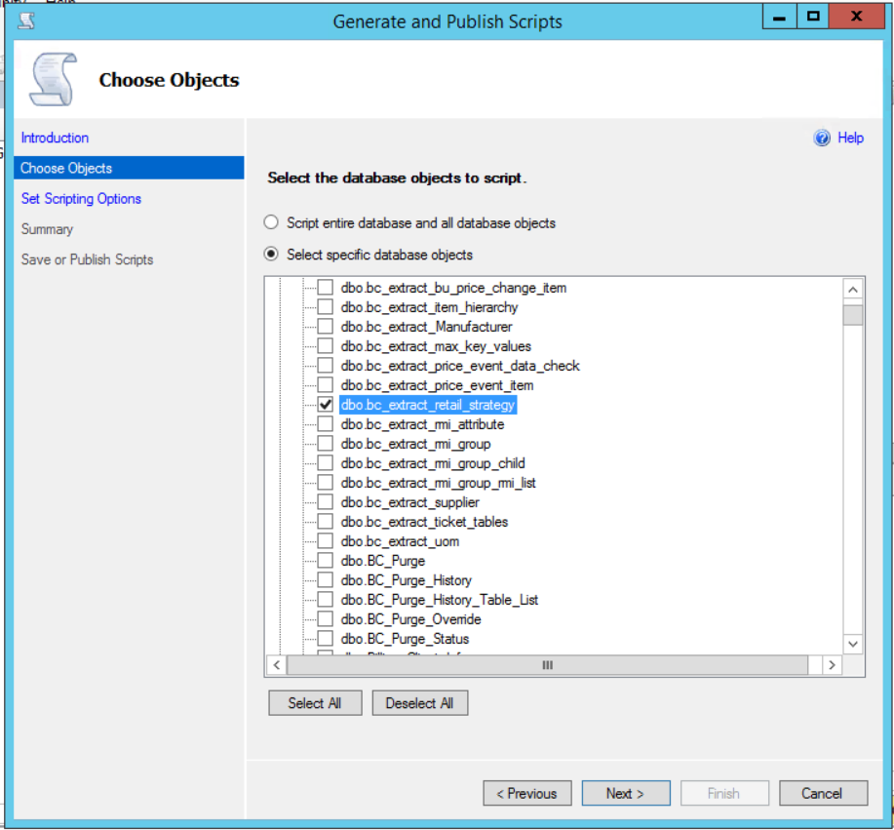

The Scripting Options page will be display, Click on the Advanced button.

Set the “Types of data to script” to “Schema and data”. Click OK.

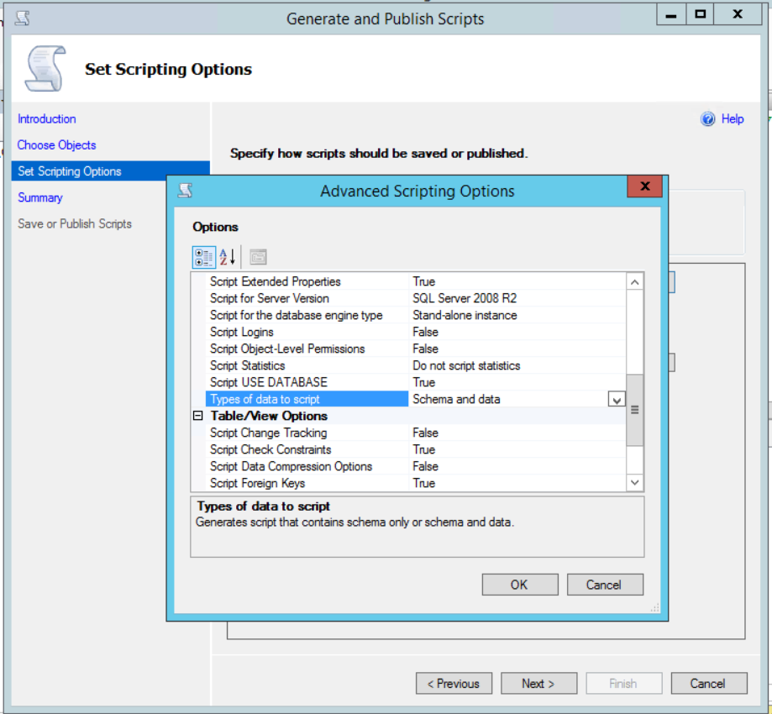

Set the option to “Save to Clipboard”. Click Next.

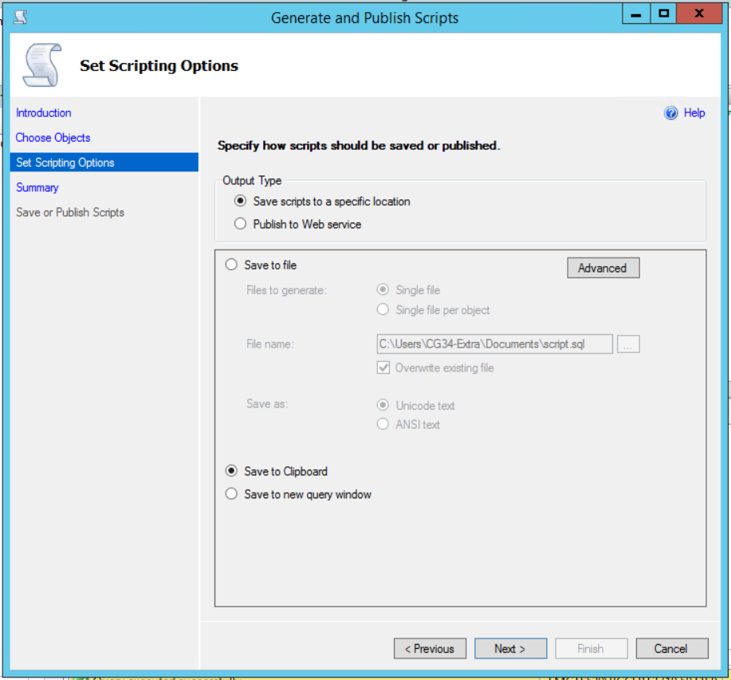

The Summary page will be displayed. Verify the information and Click Next.

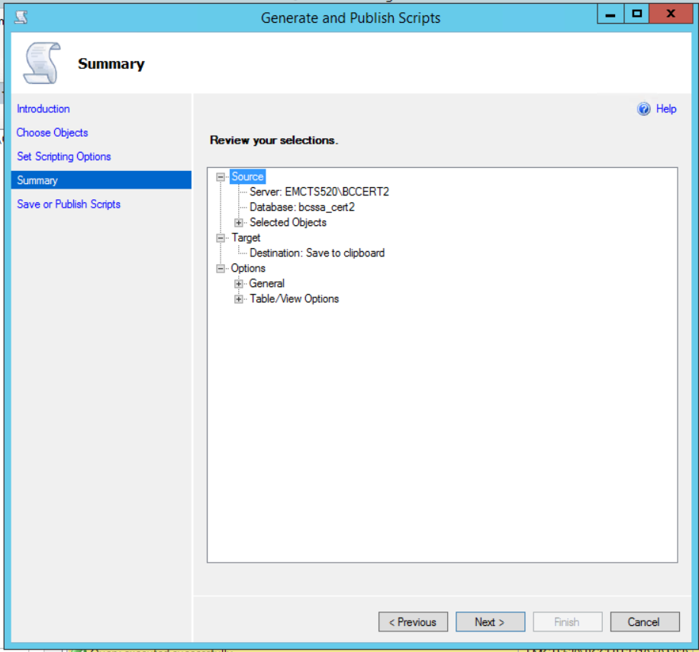

The Generate and Publish Scripts page will be displayed. Verify the result and Click Finish. The page should disappear.

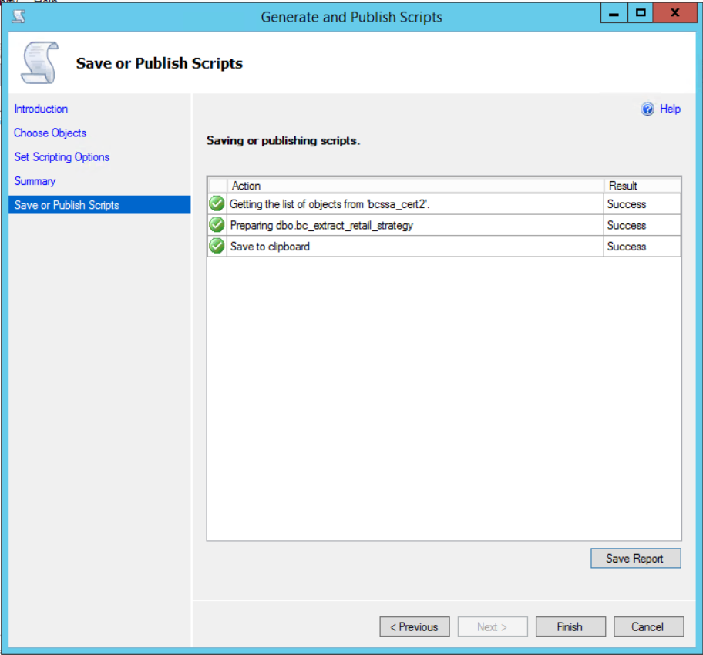

The contents of the script file are now on the clipboard.

## Insert the Destination DB.

There are two options available for this step. The data extracted in step 1 can be used or a spreadsheet can be used.

### SQL Data Extract Option.

Open the script “Step 2 - Retail Strategies Insert Dest DB (SQL Extract)” in a text editor. Select All and clear the contents of the script.

Select Paste to paste the information that was placed on the clipboard in Step 1 into the empty file.

Remove the lines of text before the create table command. It will look like this:

USE [bcssa_cert2]

GO

/****** Object: Table [dbo].[bc_extract_retail_strategy] Script Date: 11/02/2018 09:46:18 ******/

SET ANSI_NULLS ON

GO

SET QUOTED_IDENTIFIER ON

GO

Add the following to the top of the script above the create table command. This will ensure that the table is re-created:

IF OBJECT_ID('bc_extract_retail_strategy ') IS NOT NULL

DROP TABLE bc_extract_retail_strategy

GO

Save the Query

Open an instance of SQL Server Management Studio and then open a new query window. Set the database to the main BC/ESO database.

Execute the Query “Step 2 - Retail Strategies Insert Dest DB (SQL Extract)”

### Spreadsheet Option.

In the program files retail strategy folder, there is an excel file named “Template for Spreadsheet Based Strategy Import”. In the first tab there are instructions, and in the second tab there are 3 columns for the strategy, merch group, and retail level. There is a 4th column that contain a formula to generate insert statement into a worktable.

Once done, copy the values (INSERT statements) form Colum d on the second tab into the indicated area of the script "Step 2 - Retail Strategies Insert Dest DB (Spreadsheet Based).sql." Before doing so, remove any prior insert statements that may exist in the script.

When the script is edited and saved, Open an instance of SQL Server Management Studio and then open a new query window. Set the database to the main BC/ESO database.

Execute the Query “Step 2 - Retail Strategies Insert Dest DB (Spreadsheet Based)”

## Create the Retail Strategies

This step is applicable to both SQL Extract and Spreadsheet based options.

Open an instance of SQL Server Management Studio and then open a new query window. Set the database to the main BC/ESO database.

Execute the Query “Step 3 - Retail Strategies Create Strategies”.

Ensure that no errors and encountered and that data was inserted into the Merch_Group, Merch_Group_Member and Merch_Level tables.

## Clean up

If needed, go to both the source and destination databases and drop the table bc_extract_retail_strategy. There is a script available in the program files – clean up folder to delete all bc_extract tables.